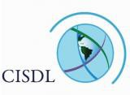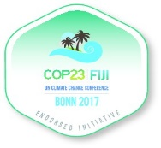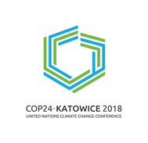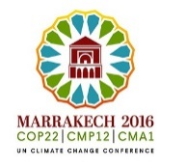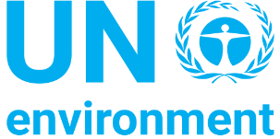

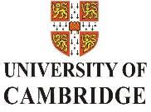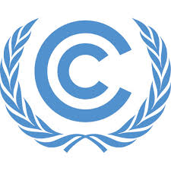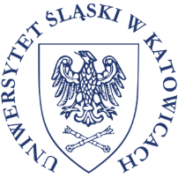

Climate Law & Governance Specialization Course

09:30-14:00 on Sunday, 9 December 2018 during UNFCCC CoP24
Faculty of Law & Administration, University of Silesia, ul. Bankowa 11b, 40-007 Katowice, Poland

BUILDING CAPACITY FOR CLIMATE LAW & GOVERNANCE

Laws and institutions can help or hinder climate action. They are crucial instruments for promoting sustainable development, and making finance flows consistent with a pathway towards low-GHG and climate-resilient alternatives, as sought by the 2015 Paris Agreement.

In order to raise awareness and strengthen capacity on legal and institutional climate reforms and frameworks, the Climate Law and Governance Initiative, which also coordinates the annual knowledge sharing event Climate Law and Governance Day, will convene a capacity building course with the support of many of its key partners. Building on the CLGI course held in 2017 in Bonn during UNFCCC COP23 and in Setatt during UNFCCC COP22, the course will take place alongside the CoP24 in Katowice on Sunday, 9 December 2018. As leading climate law and governance experts join over 15,000 delegates and observers for CoP 24, the course will provide an opportunity for delegates, observers and advanced students to profit from the insights of renowned experts so as to deepen their understanding of the legal and institutional mechanisms available to implement their (i)NDCs and the Paris Agreement.

This interactive capacity-building course will introduce participants to timely issues concerning legal and governance challenges and opportunities for the implementation of the NDCs and the Paris Agreement. Amongst others, this includes laws to strengthen adaptation and resilience, laws of promote renewable energies, climate finance, transparency provisions and the Paris Agreement, human rights law and climate change, loss and damages and climate displacement.

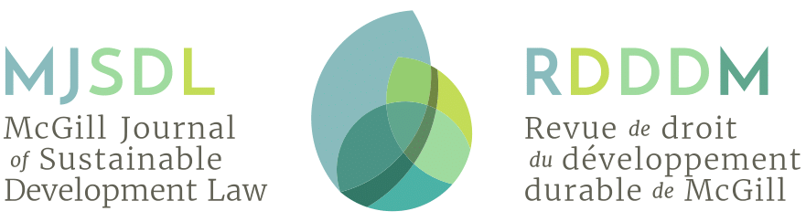

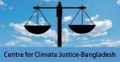
With all appreciation to our international partners:

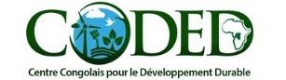

Climate Law & Governance Specialization Course

09:30-14:00 on Sunday, 9 December 2018 during UNFCCC CoP24
Faculty of Law & Administration, University of Silesia, ul. Bankowa 11b, 40-007 Katowice, Poland

COURSE PROGRAMME & LECTURERS
9:30 Registration
10:00 Opening & Introductions
Host: Prof. Barbara Mikolajczyk. Professor, Univ Silesia
Chairs: Prof Marie-Claire Cordonier Segger, Senior Director, Centre for Intl Sust Dev Law (CISDL) / Full Professor, Univ Waterloo & Dr Markus Gehring, Lecturer, Univ Cambridge
Opening Remarks: Prof. Barbara Mikolajczyk, Professor, Univ Silesia

10:10 – 10:20 Foundations: Understanding the Paris Agreement under the UNFCCC
Lecturer: Maitre Ayman Cherkaoui, Special Advisor, CoP22 Presidency / Lead Counsel,
CISDL / Executive Director, Global Compact Morocco

10:20 – 11:20 Session 1: Law, Governance & Climate Adaptation/Resilience
Lecturers: Maitre Hafij Khan, Executive Director, Climate Justice Centre – Bangladesh, on adaptation & legal aspects of loss & damage & Dr Cosmin I. Corendea, O.P. Jindal Global Univ, India, on climate migration (15 mins)
Small groups exercise (30 mins) & Report-Back (10 mins)

11:20 – 12:20 Session 2: Law, Governance & Climate Mitigation
Lecturers: Dr Markus Gehring, Law Lecturer, Univ Cambridge on climate mitigation / NDCs and on international emissions trading & flexibility mechanisms under the Paris Agreement & Maitre Miguel Saldivia, Legal Fellow, CISDL, on climate mitigation / clean energy transitions (15 mins)
Small groups exercise (30 mins) & Report-Back (10 mins)

12:20 Light Health Break (20 mins)

12:40 – 13:40 Session 3: Climate Finance, Transparency & Accountability
Lecturers: Maitre Christopher Campbell-Durufle, Legal Fellow, CISDL, on transparency & accountability mechanisms;
Dr. Patrícia G. Ferreira, Fellow, CIGI & Ass. Prof., Windsor Univ (15 mins)
Small groups exercise (30 mins) & Report-Back (10 mins)

1:30 Closing Ceremony / Awarding of Certificates for Participants
Presentation of Certificates: Prof Marie-Claire Cordonier Segger (CISDL) & Prof. Dr. Marilyn Averill, Senior Fellow, Getches-Wilkinson Center Natural Resources, Energy & Environment, Univ Colorado & Steering Committee, UNFCCC RINGOs
Congratulations & Closing Remarks: Prof Barbara Mikolajczyk, Professor, Univ Silesia

2:00 CLGI Thanks & Acknowledgements
Presentation: Ms Annika Brouwer, Programme Coordinator, CLGI

