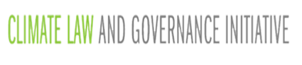
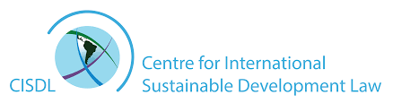

BUILDING CAPACITY FOR CLIMATE LAW & GOVERNANCE
Climate Law & Governance
Specialization Course

An interactive, intensive, capacity-building course on Paris Agreement implementation and climate law and governance innovations taught by renowned experts during the UNFCCC COP26 in Glasgow

November 2021, 09:30 - 14:30 | The Technology and Innovation Centre, University of Strathclyde

Course Programme & Lecturers

With all appreciation for the endorsement of the UNFCCC CoP22, 23, 24, 25, and 26 Presidencies

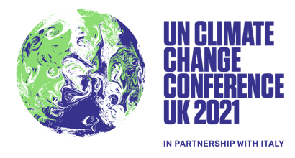
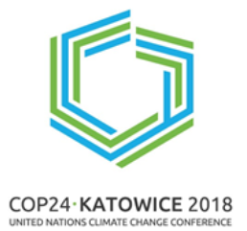
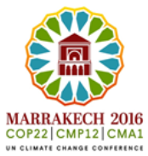



With special thanks to experts from leading international organisations for their guidance and support:
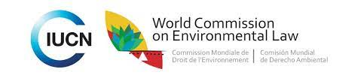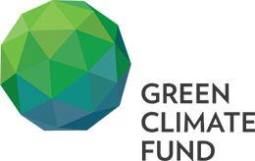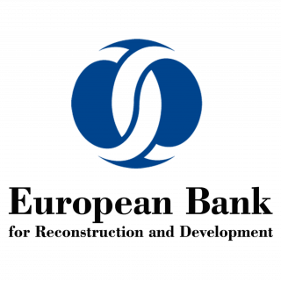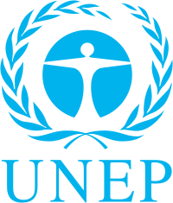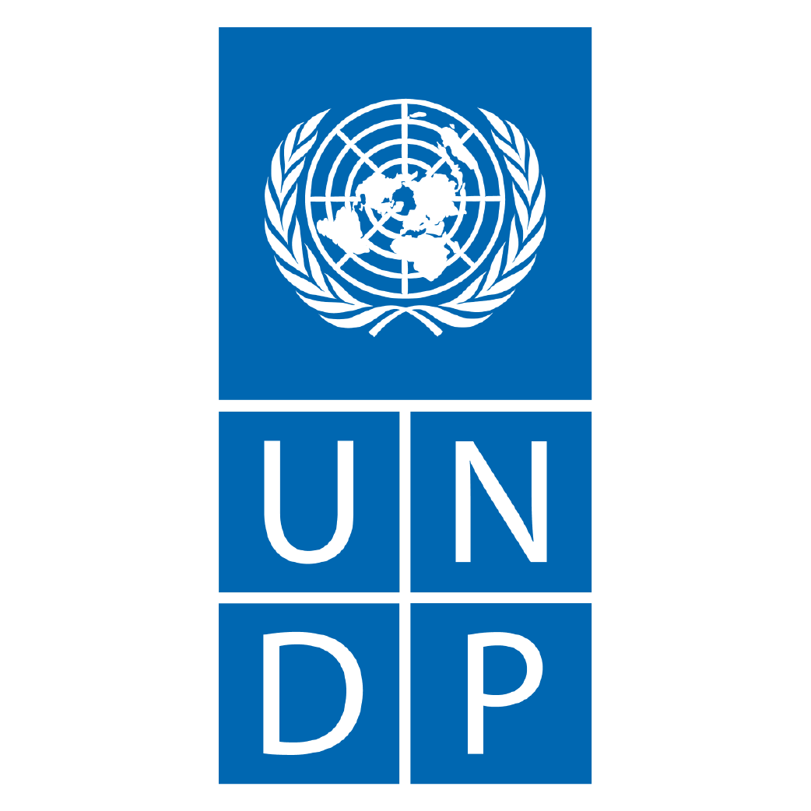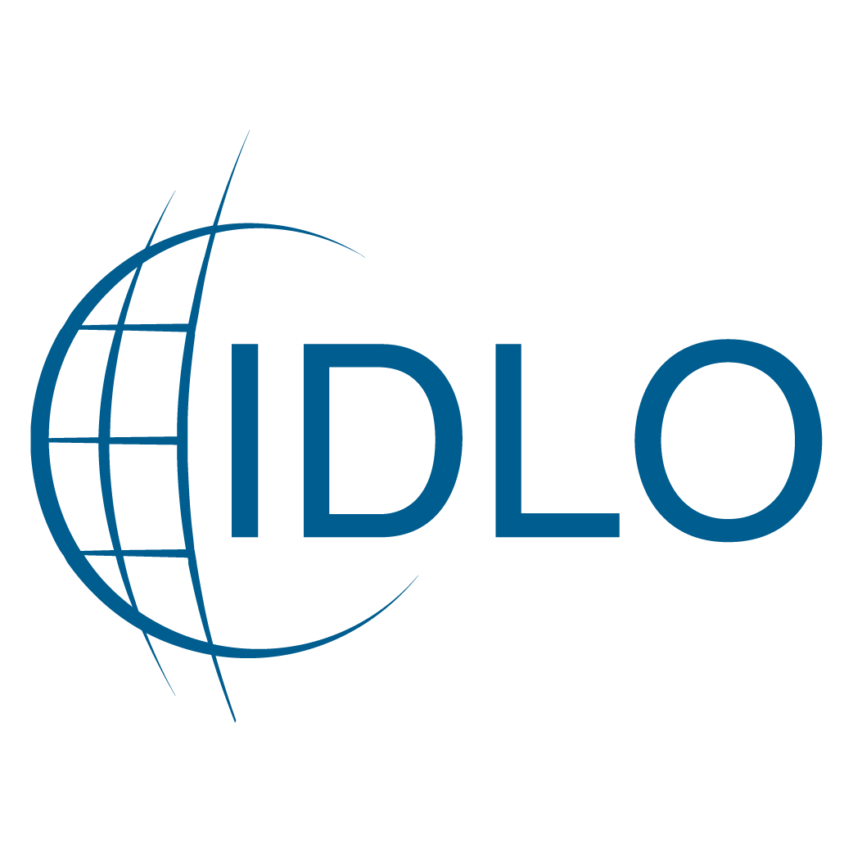

Climate Law & Governance Specialization Course
(University of Strathclyde, 7th November 2021 | 9:30-14:30)

COURSE PROGRAMME & LECTURERS

9:30 Registration

10:00 Opening & Introductions
Chair: Prof Marie-Claire Cordonier Segger (Leverhulme Trust Visiting Professorship / Climate Law & Governance Initiative, CISDL / SEED, University of Waterloo)

Opening Remarks: Dr. Claire McDiarmid (Head of Law School, University of Strathclyde)
Prof. Francesco Sindico (WCEL IUCN / University of Strathclyde)
Maitre Ayman Cherkaoui (WCEL IUCN / Mohammed VI Foundation)

10:10 – 10:20 Foundations: Understanding the Paris Agreement under the UNFCCC
Speaker: Prof Marie-Claire Cordonier Segger (Leverhulme Trust Visiting Professorship / Climate Law & Governance Initiative, CISDL / SEED, University of Waterloo)

10:20 – 11:20 Session 1: Law, Governance & Climate Mitigation
Lecturers: Dr. Markus Gehring (CELS, Faculty of Law, University of Cambridge/CISDL)
Prof. Michael Mehling (MIT/University of Strathclyde)

11:20 – 12:20 Session 2: Climate Law & Governance on Adaptation, Loss and Damage
Lecturers: Maitre Ayman Cherkaoui (CISDL / Mohammed VI Foundation)
Adv M. Hafijul Islam Khan (University of Waterloo / Centre for Climate Justice Bangladesh)

12:20 Light Break (20 mins)

12:40 – 13:40 Session 3: Climate Law & Governance on Finance, Compliance & Transparency
Lecturers: Ms. Vesselina Haralampieva (Senior Counsel, EBRD)
Dr. Alexandra Harrington (CISDL, Fullbright Canada Foundation Special Fellow)

13:40 Networking Break (20 mins)

14:00 Closing Ceremony/Awarding of Certificates for Participants
Presentation of certificates: Prof. Marie-Claire Cordonier Segger
Dr. Claire McDiarmid (Head of Law School, University of Strathclyde)

Congratulations and Closing Remarks: Dr. Claire McDiarmid (Head of Law School, University of Strathclyde)

14:20 CLGI Thanks & Acknowledgements
Presentation: Ms. Chantalle Byron (CLGI Secretariat Coordinator)

